**JOURNAL 1,2,3**

**UNIX & SHELL PROGRAMMING**

**PRAJAPATI SHIV K**

**ID:20BCA117[DIV B]**

**JOURNAL 1**

1.Print currunt month calendar.

Code:

$ cal

Output:

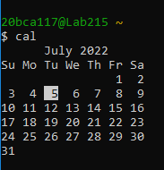

2.Print calender of may,june and july of previous year.

Code:

$ cal -3 20 06 2021

Output:

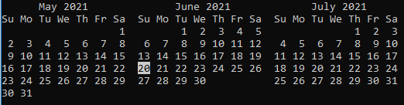

3.Convert decimal number to hexadecimal.

Code:

$ bc

ibase=10

obase=16

Output:

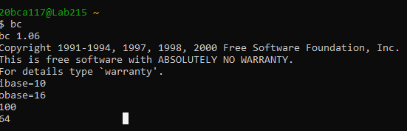

4. Display following message by applying one command.

Hello Everyone.

Today's Date is: (Example: 12 jul 2021)

Code:

$ echo Hello Everyone;date +"%d %h %y"

OutPut:

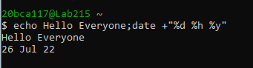

5. Display following message by applying one command.

Hello Everyone.

Today is <Print weeday name is long >(Example: today is Sunday)

Code:

$ echo "hello everyone";echo "today is" $(date +%A);

OutPut:

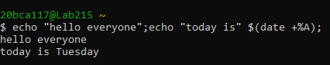

6. Check your currunt directory.

Code:

$ pwd

OutPut:

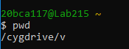

7. create a folder "UNIX", "ASP" and "PHP" in "v:\" drive.

Code:

$ mkdir UNIX ASP PHP

OutPut:



8.move to Directory "UNIX".

Code:

$ cd UNIX

OutPut:

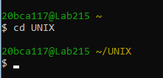

9. Creat 2 more directories "Assignment" and "Test" in "UNIX" Directories

Code:

$ mkdir {Assignment,Test};

OutPut:



10.move to Directory "PHP" With only one command

Code:

$ cd PHP

OutPut:

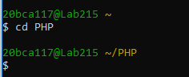

11. create a folder "UNIX", "ASP" and "PHP" in "v:\" drive.

Code:

$ mkdir UNIX ASP PHP

Answer:

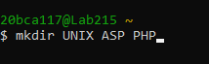

12. Create a directory "Web" under "ASP" Directory without moving from the "PHP" directory.

Code:

$ mkdir ../ASP/Web

Answer:



13. Create Directory "Project", "Temp" & "Exam" under "Web" directory resides in "ASP" Without moving from "PHP" directory.

Code:

$ mkdir ../ASP/Web/Project ../ASP/Web/Temp ../ASP/Web/Exam

Answer:



14. Create empty files "test1","test2" & "test3" in one one command in currunt directories.

Code:

$ touch test1 test2 test3

Answer:



15. Display Previous working directory

Code:

$ cd -

OutPut:

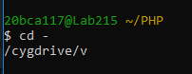

16. Write 3 different way to move to home directory.

Code:

$ cd

$ cd ~

$ cd $home

OutPut:

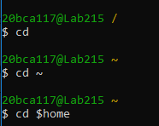

**JOURNAL 2**

1.Delete directory "ASP" with all its sub-dirctory with single command.

Code:

rm –r Asp

OutPut:



2. Move to the "Web" directory under "ASP" and create following files.

1) Create a "Stud" file which contain 5 student information(id,name,city,dob,mob) seperated field with ",".

2) Also Create "Intro" file and write more than 5 line about you..

Code:

cd asp

cd web

1.cat>Stud.txt

2.cat>Intro.txt

OutPut 1:

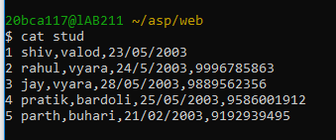

OutPut 2:

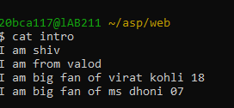

3.Create another file "Kernel" which contain list of feature of kernel and copy it into "OS" file using cat command.

Code:

$ cat kernel

$ cat kernel>os

OutPut:

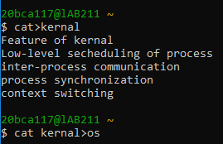

4.Append data into "Intro" file with more than 10 line about you . Add multiple blank line in file.

Code:

$ cat >> intro

OutPut:

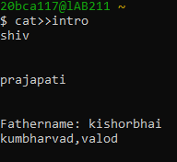

5.Make a copy of "Stud" file and call it "Stud.bk" and save it under the same directory.

Code:

$ cat stud stud.bk

OutPut:



6.Display both file with visual character and line number.

Code:

Cat -n stud

OutPut:

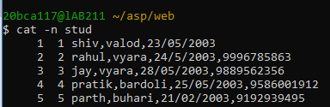

7.Count the total number of lines in "Stud" file with words and character.

Code:

Wc stud

OutPut:

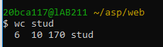

8.List out all directory created in your drive.

Code:

OutPut:

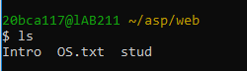

9.Recursively list all directory in your drive.

Code:

$ls –r

OutPut:

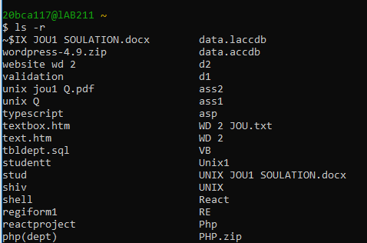

10. Display long listing details of all files and folder in "Web" directory with hidden file.

Code:

Ls –a

Output:

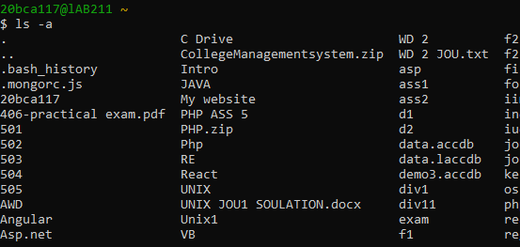

11. List out all files including hidden file in current directory in reverse order.

Code:

Ls –r

Output:

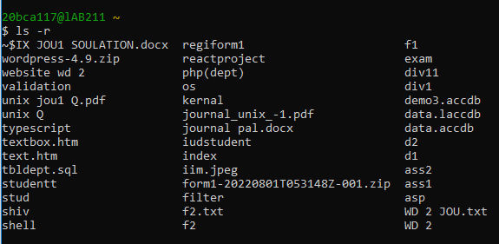

12 List all files and directory in sorting order as per its size.

Code:

Ls -S

Output: 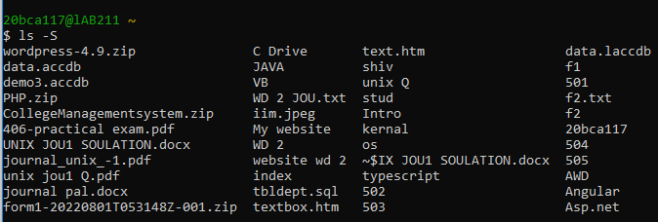

13.List all files details as per its modification time

Code:

Ls -t

Output:

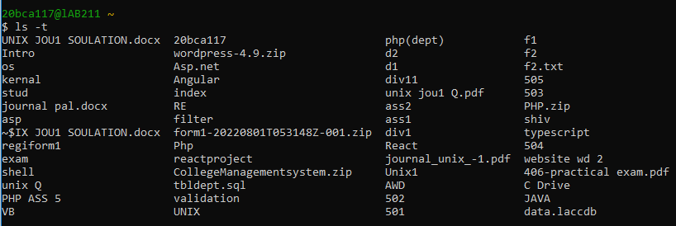

14. Copy & rename"Stud" and "Into" file into "Temp" folder of "Exam" in single command. Use interactive option.

Code:

$ mv intro into | mv stud stud1 ../php/exam/stud.txt

Output:



15. Copy "Intro" file in "web" folder under ASP to the parent directory using dot notation.

Code:

$cp intro.txt ../..

Output:



16.Copy Exam folder from "PHP" to "UNIX".

Code:

Cp –r exam ../UNIX

Output:



17. Recursiverly copy entire "Web" folder into "PHP".

Code:

Cp –r web PHP1

Output:



18. Rename "Stud" file with "Student".

Code:

$mv stud.txt stud .txt

Output:



19.Remove "temp" folder with all its subdirectories and files.

Code:

$rm stud.bk

Output:



20. Create a empty file temp1,temp2 and temp* in UNIX directory. Delete only temp* file.

Code:

$rm –r temp

Output:



21. Forcefully delete all file from php directory.

Code:

$ rm –rf PHP1

Output:



22.Move "Student" file into "UNIX".

Code:

$mv student.txt UNIX/

Output:



23.To Find file having a .txt extention

Code:

$find *.txt

Output:

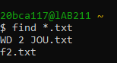

24.To Find file having size greater than 5

Code:

$find ~ -size +5b

Output:

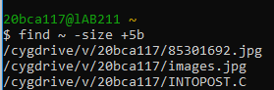

**JOURNAL 3**

1.Create two files under "UNIX" directory name "BCA" and "BBA" withduplicate records( student id,name, city, Pincode, Sem, DOB).

Enter city "Bardoli" In more than 3 records.

Enter duplicate records also.

Date should be in dd/mm/yyyy format. Not Enter heading in file. See Below example.

( Example : 1 | OM | BARDOLI | 394601 | 5 | 11/08/1992 )

Code:

$ cat > BCA

$ cat > BBA

Output:

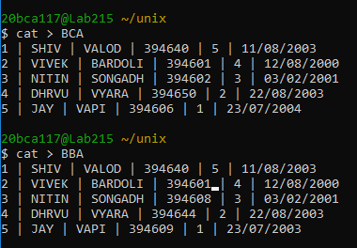

2.Write command to display first five lines from file "Intro" under "Web" Directory.

Code:

$ head –n5 introo.txt

Output:

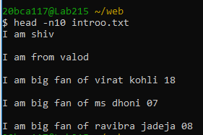

3.Display first 5 character of file "intro".

Code:

$ head –c5 introo.txt

Output:



4.Count number of character from first five lines of file "Intro".

Code:

$ head –n5 introo.txt | wc -c

Output:



5.List 3 most recently used file in PWD.

Code:

$ ls -lt

Output:

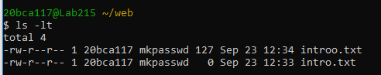

6 Display last five lines from file "Intro" under "Web" Directory.

Code:

$ tail –n5 introo.txt

Output:

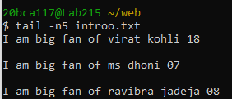

7.Count number of character in last line of "intro" file.

Code:

$ tail introo.txt | wc -c

Output:



8.Display lines 4 to 9 from file "Intro".

Code:

$ head -9 introo.txt | tail +4

Output:

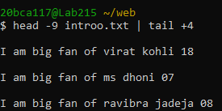

9.Display two lines starting from 7th line of file "intro".

Code:

$ head –n8 introo.txt | tail -2

Output:

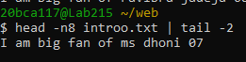

10.Count number of words in line 8 to 12 in file "intro".

Code:

$ head –n12 introo.txt | tail -5 |wc -c

Output:

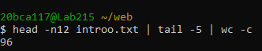

11.Display last five character of file "intro".

Code:

$ tail –c5 introo.txt

Output:



12.Display characters from 2oth byte of "Intro".

Code:

$ tail –c+20 introo.txt

$ tail –c20 introo.txt

Output:

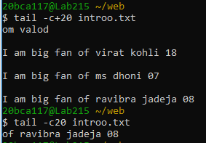

13.Display only 1st character of each lines.

Code:

$ cut –c 1 introo.txt

Output:

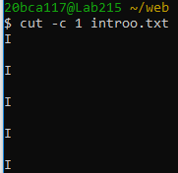

14.Display only 5 to 8 character of each lines.

Code:

$ cut –c 5,6,7,8 introo.txt

Output:

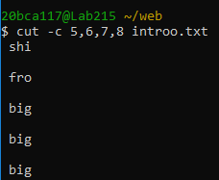

15.Display first 5 character of each lines.

Code:

$ cut -c -5 introo.txt

Output:

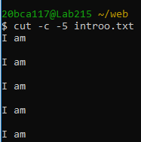

16.Display only 2nd field from "Stud" file of "Web".

Code:

$ cut –d “,” –f2 stud.bk

Output:

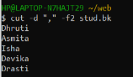

17.Display only 2nd to 3rd field from "Stud" file o"Web".

Code:

$ cut –d “,” –f2,3 stud.bk

Output:

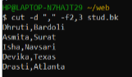

18.Display only 2,3, and 5 field form "Stud" file.

Code:

$ cut –d ”,” –f2,3,5 stud.bk

Output:

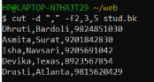

19.To Print field 2 to 5 from "stud" file.

Code:

$ cut –d “,” –f2-5 stud.bk

Output:

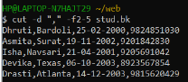

20.Merging two file "BCA" and "BBA" with delimiter ":".

Code:

$ paste –d ‘:’ BBA BCA

Output:

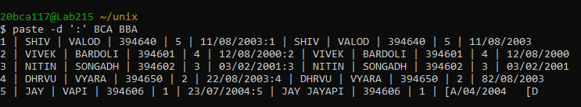

21.Sort File "BCA" .

Code:

$ sort BCA

Output:

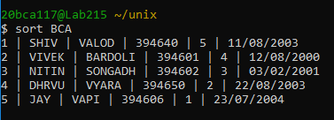

22.Sort File "BBA" and display only unique records. Use delimiter "|"

Code:

$ sort BBA | uniq

Output:

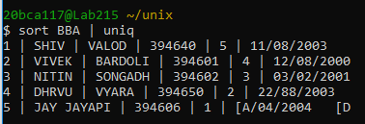

23.Sort File "BCA" on "ID" field.

Code:

$ sort –k1,1 BCA

Output:

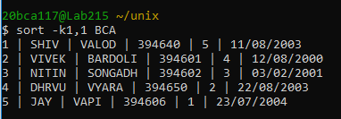

24.Sort file "BBA" on "Pincode" which is a numeric field in decending order.

Code:

$ sort –r –k4n,4 BBA

Output:

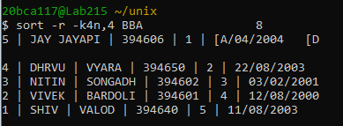

25.Sort file "BCA" on multiple field "ID" and "City" use delimiter ","

Code:

$ sort –t ‘|’ –k1n,3 BCA

Output:

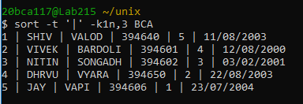

27.Sort file by last access time.

Code:

$ ls –l | sort –k8 –k8.4,8.5n

Output:

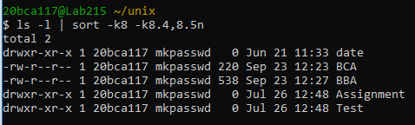

28.Display number of unique line in file "BCA".

Code:

$ uniq –c BCA

Output:

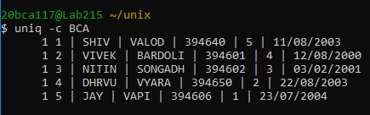

29.Display unique line from file "BCA".

Code:

$ uniq BCA

Output:

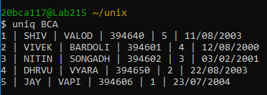

30.To remove duplicate line from a file "BBA".

Code:

$ uniq –u BBA

Output:

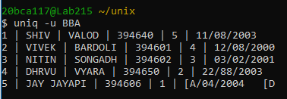

31.Display only duplicate line in file "BBA".

Code:

$ uniq –d BBA

Output:



32.Print frequency of each line from file "BCA"

Code:

$ cat BCA | tr –s ‘ ‘ ‘\n’ | sort |uniq –c |awk ‘{print$2,$1}’

Output:

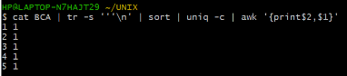

33.Move to "Web" Directory

Code:

$ cd asp

$ cd web

Output:

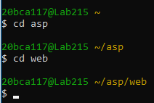

34.Translate "Intro" file into "Upper case".

Code:

$ tr [a-z][A-Z] < introo.txt

Output:

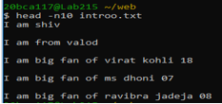

35.Translate "Stud" file with delimiter "-" and print only 3 records.

Code:

$ cat stud.txt | tr ‘,-‘ ‘-‘ | head -3

Output:

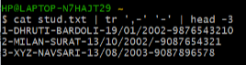

36.Delete vowel from "Intro" files.

Code:

$ tr –d [a,e,i,o,u] < introo.txt

Output:

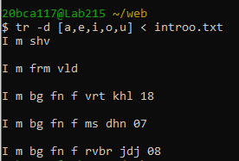

37.Remove all leading spaces from file "Into".

Code:

$ tr –s “ “ < introo.txt

Output:

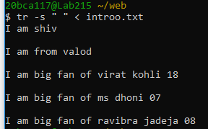

38.To delete all special character in "BCA" file.

Code:

$ cat BCA | tr –d ‘||’

Output:

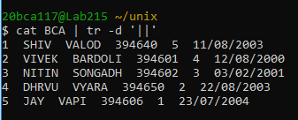

39.Replace multiple space between two words with single space.

Code:

$ cat ibtro.txt | tr –s ” “

Output:

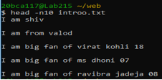

40.Write a command to sort a line of "BCA" file and remove repeated lines.

Code:

$ cat BCA | uniq

Output:

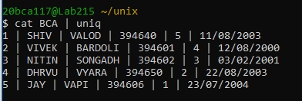

41.Replace all occurance of "Bardoli" with "Baroda" in"BBA".

Code:

$ tr “VALOD” “BARDOLI” < BBA

Output:

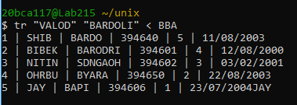

42.Replace all occurance of "Bardoli" with "Baroda" in 5th line of "BCA"

Code:

$ head -5 BCA tail +5 | tr “VALOD” “BARDOLI”

Output:

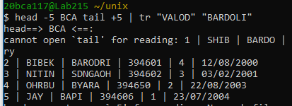

43.Count all occurance of "My" in "Intro" file

Code:

$ cut –f 1 introo.txt | grep –I “My” | wc -l

OutPut:



44.To Count the number of words in line 5 to line 10 of file "Intro".

Code:

$ head -10 introo.txt | tail +5 | wc -c

Output:

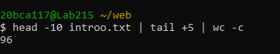

45.To move all files begin with digit from parent directory to the current directory.

Code:

Output